/* **ScienceQtech Employee Performance Mapping.*/**

//To facilitate a better understanding, managers have provided ratings for each employee which will help the HR department to finalize the employee performance mapping. As a DBA, you should find the maximum salary of the employees and ensure that all jobs are meeting the organization's profile standard. You also need to calculate bonuses to find extra cost for expenses. This will raise the overall performance of the organization by ensuring that all required employees receive training.//

select * from data_science_team;

select * from emp_record_table;

select * from proj_table;

//****1. Create a database named employee, then import data_science_team.csv proj_table.csv

and emp_record_table.csv into the employee database from the given resources.****//

copy emp_record_table from 'G:\SQL TRAINING\Project1\emp_record_table.csv' delimiter ',' csv header;

copy proj_table from 'G:\SQL TRAINING\Project1\proj_table.csv' delimiter ',' csv header;

copy data_science_team from 'G:\SQL TRAINING\Project1\data_science_team.csv' delimiter ',' csv header;

/*2. Create an ER diagram for the given employee database.*/

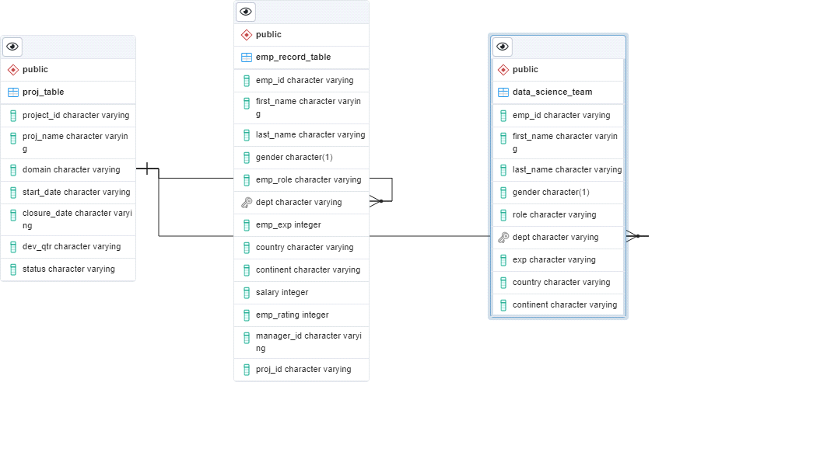

//****3. Write a query to fetch EMP_ID, FIRST_NAME, LAST_NAME, GENDER, and DEPARTMENT from the

employee record table, and make a list of employees and details of their department.****//

select EMP_ID,FIRST_NAME,LAST_NAME,GENDER,DEPT from emp_record_table;

//****4 Write a query to fetch EMP_ID, FIRST_NAME, LAST_NAME, GENDER, DEPARTMENT, and EMP_RATING if the EMP_RATING is:

less than two

greater than four

between two and four****//

select EMP_ID,FIRST_NAME,LAST_NAME,GENDER,DEPT, EMP_RATING from emp_record_table where EMP_RATING<2;

select EMP_ID,FIRST_NAME,LAST_NAME,GENDER,DEPT, EMP_RATING from emp_record_table where EMP_RATING>4;

select EMP_ID,FIRST_NAME,LAST_NAME,GENDER,DEPT, EMP_RATING from emp_record_table where EMP_RATING between 2 and 4;

//****5 Write a query to concatenate the FIRST_NAME and the LAST_NAME of employees in

the Finance department from the employee table and then give the resultant column alias as NAME.****//

select concat(FIRST_NAME,' ',LAST_NAME)as Name from emp_record_table where dept='FINANCE';

//**** 6 Write a query to list only those employees who have someone reporting to them.

Also, show the number of reporters (including the President).****//

select * from emp_record_table

//****7 Write a query to list down all the employees from the healthcare and finance

departments using union. Take data from the employee record table.****//

select * from emp_record_table where dept='HEALTHCARE'

UNION

select * from emp_record_table where dept='FINANCE';

/****8 Write a query to list down employee details such as EMP_ID, FIRST_NAME, LAST_NAME, ROLE, DEPARTMENT,

and EMP_RATING grouped by dept. Also include the respective employee rating along with

the max emp rating for the department.****//

select emp_id, FIRST_NAME, LAST_NAME, emp_role, dept,EMP_RATING,

(select max(emp_rating) from emp_record_table b where a.dept = b.dept )as maxRating

from emp_record_table a

order by a.dept

//****9 Write a query to calculate the minimum and the maximum salary of the employees in each role.

Take data from the employee record table.****//

select emp_role,min(salary) as minSalary, max(salary) as maxSalary

from emp_record_table

group by emp_role

//****10 Write a query to assign ranks to each employee based on their experience.

Take data from the employee record table.****//

select emp_id, emp_exp, RANK () OVER ( ORDER BY emp_exp desc) as rank_number

from emp_record_table

//****11 Write a query to create a view that displays employees in various countries

whose salary is more than six thousand. Take data from the employee record table.****//

create view view_SalaryMoreThanSixThousand

as

select * from emp_record_table where salary > 6000

select * from view_SalaryMoreThanSixThousand

//****12 Write a nested query to find employees with experience of more than ten years.

Take data from the employee record table.****//

select * from emp_record_table where emp_id in (select emp_id from emp_record_table where emp_exp >10)

//****13 Write a query to create a stored procedure to retrieve the details of the employees

whose experience is more than three years. Take data from the employee record table.****//

create or replace FUNCTION FN_GetEmployeeByExp()

returns setof emp_record_table

AS

$func$

SELECT *

FROM emp_record_table

where emp_exp > 3;

$func$

LANGUAGE sql;

select * from FN_GetEmployeeByExp()

//****14 Write a query using stored functions in the project table to check

whether the job profile assigned to each employee in the data science

team matches the organization’s set standard.

The standard being:

For an employee with experience less than or equal to 2 years assign 'JUNIOR DATA SCIENTIST',

For an employee with the experience of 2 to 5 years assign 'ASSOCIATE DATA SCIENTIST',

For an employee with the experience of 5 to 10 years assign 'SENIOR DATA SCIENTIST',

For an employee with the experience of 10 to 12 years assign 'LEAD DATA SCIENTIST',

For an employee with the experience of 12 to 16 years assign 'MANAGER'.

****//

create or replace function FN_IsMatchesStandards()

returns table ( fn_emp_id varchar, fn_role varchar,fn_emp_exp integer,fn_Role_As_Per_Standerds text, fn_Is_Role_As_Per_Standerds boolean )

language plpgsql

as $$

begin

return query

select emp_id, role, cast(exp as integer) as emp_exp,

case

when(cast(exp as integer) <= 2) then('JUNIOR DATA SCIENTIST')

when(cast(exp as integer) between 3 and 5 ) then('ASSOCIATE DATA SCIENTIST')

when(cast(exp as integer) between 6 and 10 ) then('SENIOR DATA SCIENTIST')

when(cast(exp as integer) between 11 and 12 ) then('LEAD DATA SCIENTIST')

else('MANAGER')

end as Role_As_Per_Standerds,

case when role = (case

when(cast(exp as integer) <= 2) then('JUNIOR DATA SCIENTIST')

when(cast(exp as integer) between 3 and 5 ) then('ASSOCIATE DATA SCIENTIST')

when(cast(exp as integer) between 6 and 10 ) then('SENIOR DATA SCIENTIST')

when(cast(exp as integer) between 11 and 12 ) then('LEAD DATA SCIENTIST')

else('MANAGER')

end)

then true

else false

end

as Is_Role_As_Per_Standerds

from Data_science_team

order by cast(exp as integer) desc;

end ;

$$

select * from FN_IsMatchesStandards();

/?****15 Create an index to improve the cost and performance of the query to find the employee

whose FIRST_NAME is ‘Eric’ in the employee table after checking the execution plan.****//

CREATE INDEX IX_FirstNAME1 ON emp_record_table USING btree (first_name)

explain select * from emp_record_table WHERE first_name = 'Eric';

//****16 Write a query to calculate the bonus for all the employees, based on their ratings and salaries

(Use the formula: 5% of salary * employee rating).****//

SELECT emp_id,salary,emp_rating,((salary*5/100)*emp_rating) as bonus FROM emp_record_table

//****17 Write a query to calculate the average salary distribution based on the continent and country.

Take data from the employee record table.****//

SELECT continent, avg(Salary) FROM emp_record_table group by continent;

SELECT country, avg(Salary) FROM emp_record_table group by country;

select continent,

(select avg(b.Salary) from emp_record_table b where a.continent = b.continent) as continentAvg,

country,

(select avg(c.Salary) from emp_record_table c where a.country = c.country) as countryAvg

FROM emp_record_table a

group by continent,country

Created by SATYAM BAVISKAR

Links: [www.linkedin.com/in/satyam-baviskar-b9891625a](http://www.linkedin.com/in/satyam-baviskar-b9891625a)

Links: <https://github.com/Satyam1391>